Creating a KPI Donut Chart in Tableau

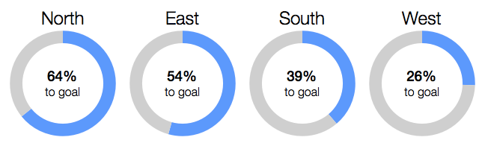

Step 1: Create a two-slice pie chart. This example uses actual sales and sales left to hit the goal.

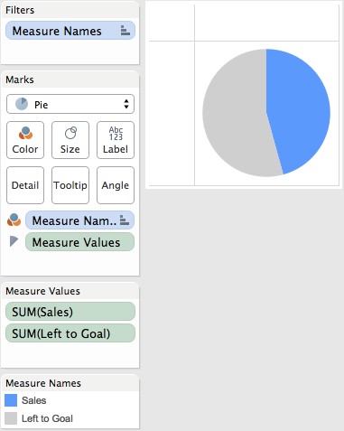

Step 2: Drag the *Number of Records* measure to the Rows shelf and change the aggregation to an average. Repeat this a second time and then right-click on the second pill and choose "Dual Axis". Finally, remember to synchronize the axes.

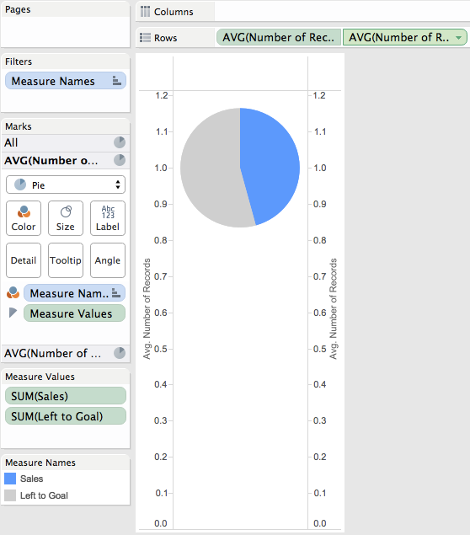

Step 3: Double click on the left axis to bring up the Edit Axis window. Uncheck Include Zero.

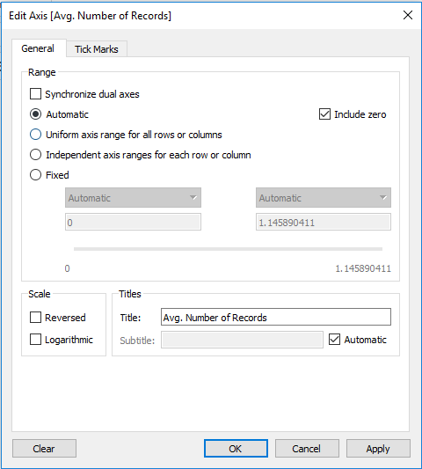

Uncheck

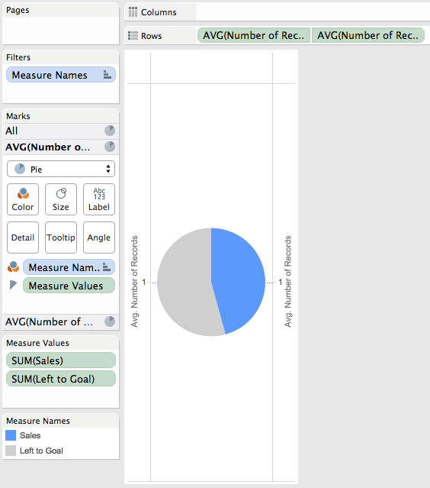

Step 4: Do a bit of formatting: (1) Remove Zero line, (2) Remove Row & Column dividers, (3) Hide the headers.(Click on the Format tab on the top axis and on the rows and columns tab set the zero lines to none.

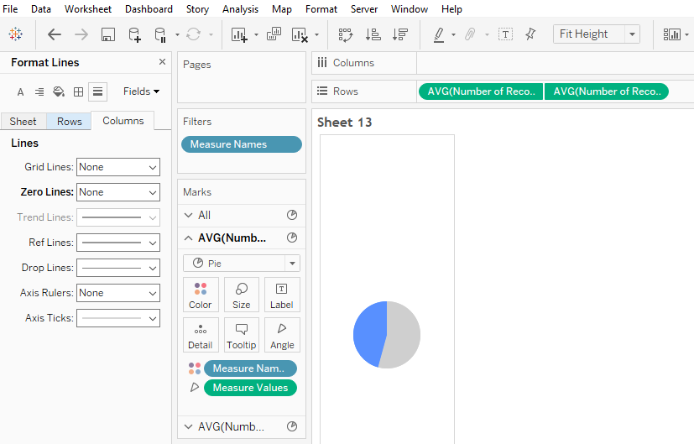

Set the zero lines to none

format

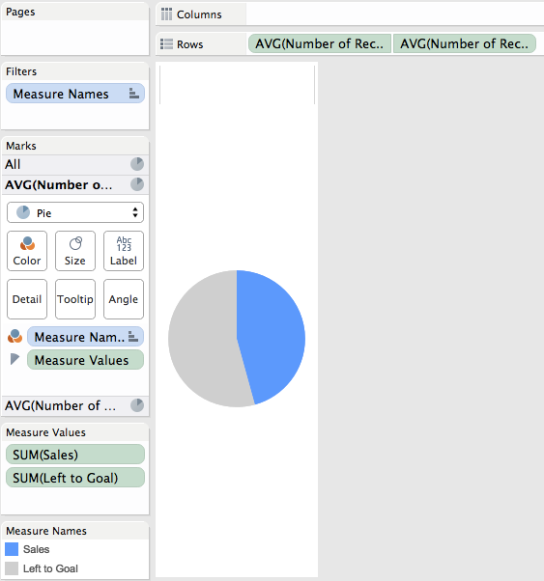

Step 5: On the secondary axis, remove Measure Names from color and Measure Values from Angle. Click the Color shelf and choose white. Adjust the size of the pie down slightly to reveal the donut.

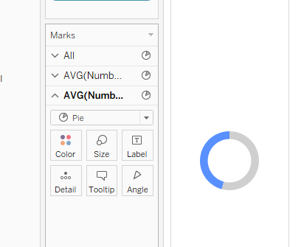

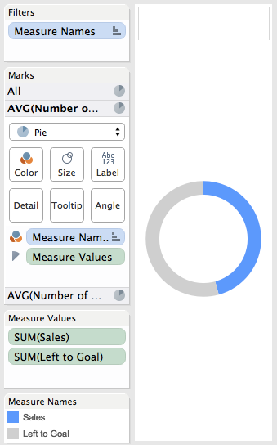

Step 6: Add Region to the Columns shelf and then hide the headers.

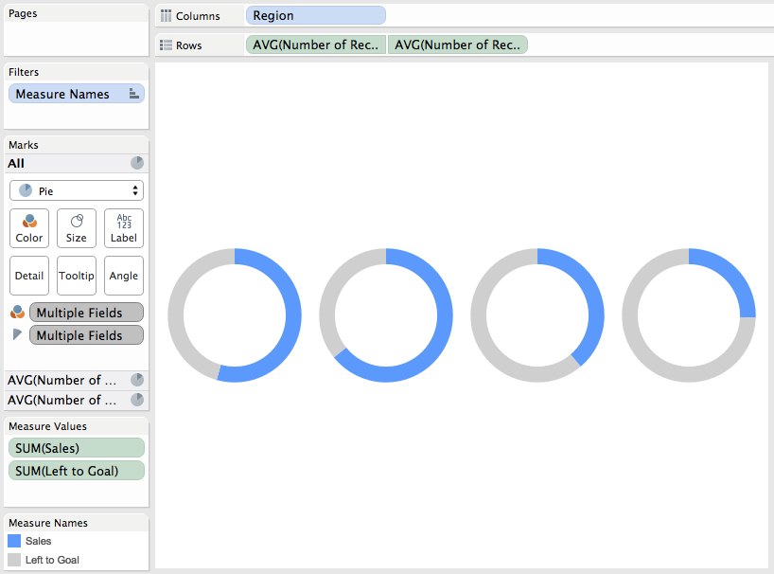

Step 7: On the first pie chart on the Marks card, add Region to the Label shelf, set the alignment to the top and make the font bigger.

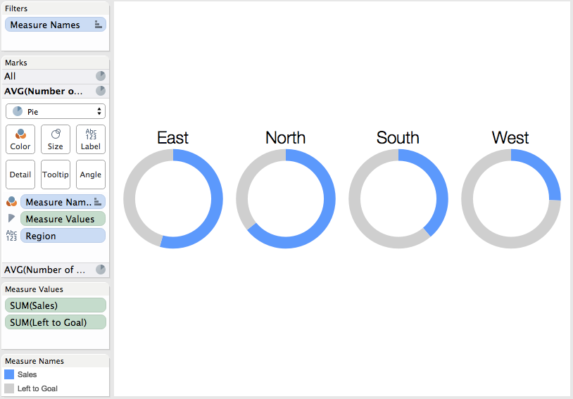

Step 8: On the second pie chart on the Marks card, add a % to goal measure to the Label shelf and customize the font.

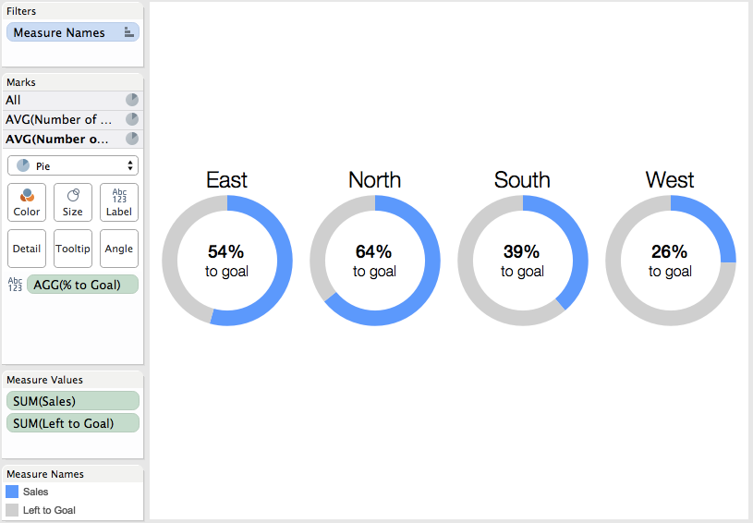

Step 9: Sort Region by the % to goal metric in descending order.

